
POWER CAT

Business Value for Power Platform
Solution User Guide
Measure, capture and visualise the business value of every app, flow and agent across the Power Platform estate.
Version 1.0 · June 2026
Microsoft Power CAT · Center of Excellence

Contents
Contents 2
1. Introduction 4
1.1 Who this guide is for 4
1.2 What you get 4
2. How the solution works 4
3. Data model 6
3.1 Application (bvp_application) 6
3.2 Value Submission (bvp_valuesubmission) 6
4. The cloud flows 7
4.1 F1 — Inventory Sync 7
4.2 F2 — Value Request Campaign 7
4.3 F3 — Capture Submission 7
4.4 F4 — Reminder & Escalation 7
4.5 F5 — Value Rollup Snapshot 7
5. Using the value dashboard 9
5.1 The header 9
5.2 The KPI tiles 9
5.3 Charts and grid 9
5.4 Submitting value as an app owner 10
6. Deploying the solution 12
6.1 Dataverse tables 12
6.2 Cloud flows 12
6.3 The Code App 12
7. Configuration 13
7.1 Settings 13
7.2 Placeholders to set before go-live 13
8. Day-to-day operations 14
8.1 Routine checks 14
8.2 Running a value campaign 14
8.3 Interpreting the numbers 14
9. Troubleshooting 15
10. Appendix 15
10.1 Choice values 15
10.2 Glossary 15

1. Introduction
The Business Value solution gives the Power Platform team a single, trustworthy answer to the question leadership asks most often: what is the platform actually worth? It discovers every app in the estate, asks each owner to estimate the time and money their app saves, stores those estimates in Microsoft Dataverse, and rolls them up into a live, branded dashboard.
This guide explains what the solution contains, how to use the dashboard, how to deploy and configure each component, and how to operate it day to day.

1.1 Who this guide is for
- Power Platform administrators and the Centre of Excellence (CoE) team who run governance.
- Solution owners who deploy, configure and maintain the components.
- Business stakeholders who read the value dashboard.

1.2 What you get
- Two Dataverse tables that hold the application inventory and the value estimates.
- Five Power Automate cloud flows that discover apps, request estimates, capture submissions, chase non-responders, and roll up totals.
- A Power Apps Code App that visualises the consolidated value with KPIs, charts and a searchable grid.

2. How the solution works
The solution runs a continuous value-capture loop. Each stage is owned by a Dataverse table, a flow, or the dashboard:
- Discover — a scheduled flow reads the tenant inventory and upserts an Application row for every app.
- Request — a campaign flow emails each app owner a link that opens the dashboard’s built-in Submit value screen, and marks the app “Requested”.
- Submit — the owner opens the app, enters hours saved and people impacted, and submits. The estimate is written straight to Dataverse.
- Capture — a flow computes the monthly and annual value and marks the app “Submitted”.
- Chase — a daily flow reminds non-responders and, after a grace period, escalates to their manager and quarantines the app.
- Roll up — a weekly flow aggregates a tenant-level snapshot for trend reporting.
- Visualise — the Code App reads the two tables live and presents the consolidated value.

The value formula
Annual value = Hours saved per person per month × People impacted × Blended hourly rate × 12
The blended hourly rate defaults to $45 and is configurable (see section 7).

3. Data model
The solution stores everything in two Dataverse tables using the publisher prefix bvp. The dashboard and flows join them on the shared Resource ID.

3.1 Application (bvp_application)
One row per Power Platform resource discovered in the inventory.
Column | Type | Purpose
Name | Text | App display name
Resource ID | Text | Inventory resource id (join key)
Resource Type | Choice/Text | Canvas / Model-driven / Code App / Flow / Agent
Environment | Text | Environment the app lives in
Owner Email | Text | Primary owner
Business Unit | Text | Operations, Finance, Supply Chain, HR, Sales, R&D
Lifecycle Status | Text | Active, Orphaned, Quarantined, Retired
Attestation Status | Text | Not Requested, Requested, Reminded, Submitted, Escalated
Last Launched | DateTime | Most recent use (from usage data)

3.2 Value Submission (bvp_valuesubmission)
One row per owner attestation of value for an application.
Column | Type | Purpose
Name | Text | Submission label (app + month)
Resource ID | Text | Links to the parent application
Hours / person / month | Decimal | Owner input
People Impacted | Whole number | Owner input
Blended Rate | Currency | Hourly rate (default $45)
Total Monthly Hours | Calculated | Hours × people
Estimated Monthly Value | Calculated | Hours × rate
Estimated Annual Value | Calculated | Monthly × 12
Confidence | Choice/Text | Low, Medium, High
Submitted By / On | Text / DateTime | Audit trail

4. The cloud flows
Five Power Automate flows automate the value-capture loop. Each is described below with its trigger and what it does.

4.1 F1 — Inventory Sync
Trigger: Scheduled · daily 02:00
- Lists every app in the tenant using the Power Apps for Admins connector.
- Creates a new Application row for apps it hasn’t seen, or updates existing rows (matched on Resource ID).
- Keeps the inventory current and consistent — the foundation everything else builds on.

4.2 F2 — Value Request Campaign
Trigger: Scheduled · weekly (Mon 08:00)
- Finds Active apps that have never attested, or whose attestation is older than the cadence window.
- Emails each owner a short request with a link to submit their estimate.
- Sets the app’s Attestation Status to “Requested” and records the request date.

4.3 F3 — Capture Submission
Trigger: Triggered · on new Value Submission
- Fires when an owner submits an estimate (from the value form or the app).
- Computes Total Monthly Hours, Monthly Value and Annual Value.
- Marks the parent application as “Submitted”.

4.4 F4 — Reminder & Escalation
Trigger: Scheduled · daily 09:00
- Reminds owners whose request is outstanding beyond the reminder window.
- After the escalation window, emails the owner’s manager (resolved via Office 365 Users) and quarantines the app.
- Ensures unresponsive owners re-engage and control is restored.

4.5 F5 — Value Rollup Snapshot
Trigger: Scheduled · weekly (Sun 23:00)
- Aggregates total annual value, total hours and response rate across the estate.
- Writes a point-in-time snapshot so leadership can see the trend over time.

5. Using the value dashboard
The dashboard is a Power Apps Code App. Open it from the Power Apps maker portal (Apps → Business Value Dashboard → Play), or from the direct play link your administrator shares.
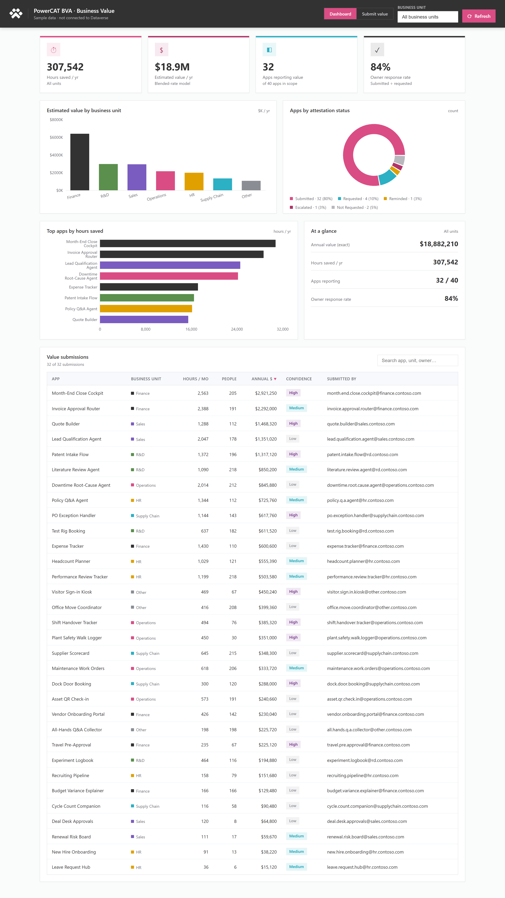
The Business Value dashboard, reading live Dataverse data.

5.1 The header
- Power CAT logo and title confirm you are in the right app; the subtitle shows whether you are on live Dataverse or sample data.
- Business unit filter — narrows every number on the page to a single business unit.
- Refresh — reloads the latest data from Dataverse.

5.2 The KPI tiles
Tile | What it means
Hours saved / yr | Total hours saved per year across reporting apps in scope.
Estimated value / yr | Total annual dollar value (hours × blended rate).
Apps reporting value | How many apps have a submission, out of all apps in scope.
Owner response rate | Submitted divided by requested — a measure of engagement.

5.3 Charts and grid
- Estimated value by business unit — where value concentrates, in $K per year.
- Apps by attestation status — the doughnut shows how much of the estate has responded.
- Top apps by hours saved — the highest-impact apps.
- Value submissions grid — searchable and sortable; click any column header to sort.

Tip
Every number recomputes when you change the business-unit filter — KPIs, charts and the grid all update together.

5.4 Submitting value as an app owner
Owners record value without leaving the app. The header has a Dashboard / Submit value switch; choosing Submit value opens a short form. The same screen opens automatically when an owner clicks the link in the request email — the email passes the app’s Resource ID so the owner’s app is pre-selected.
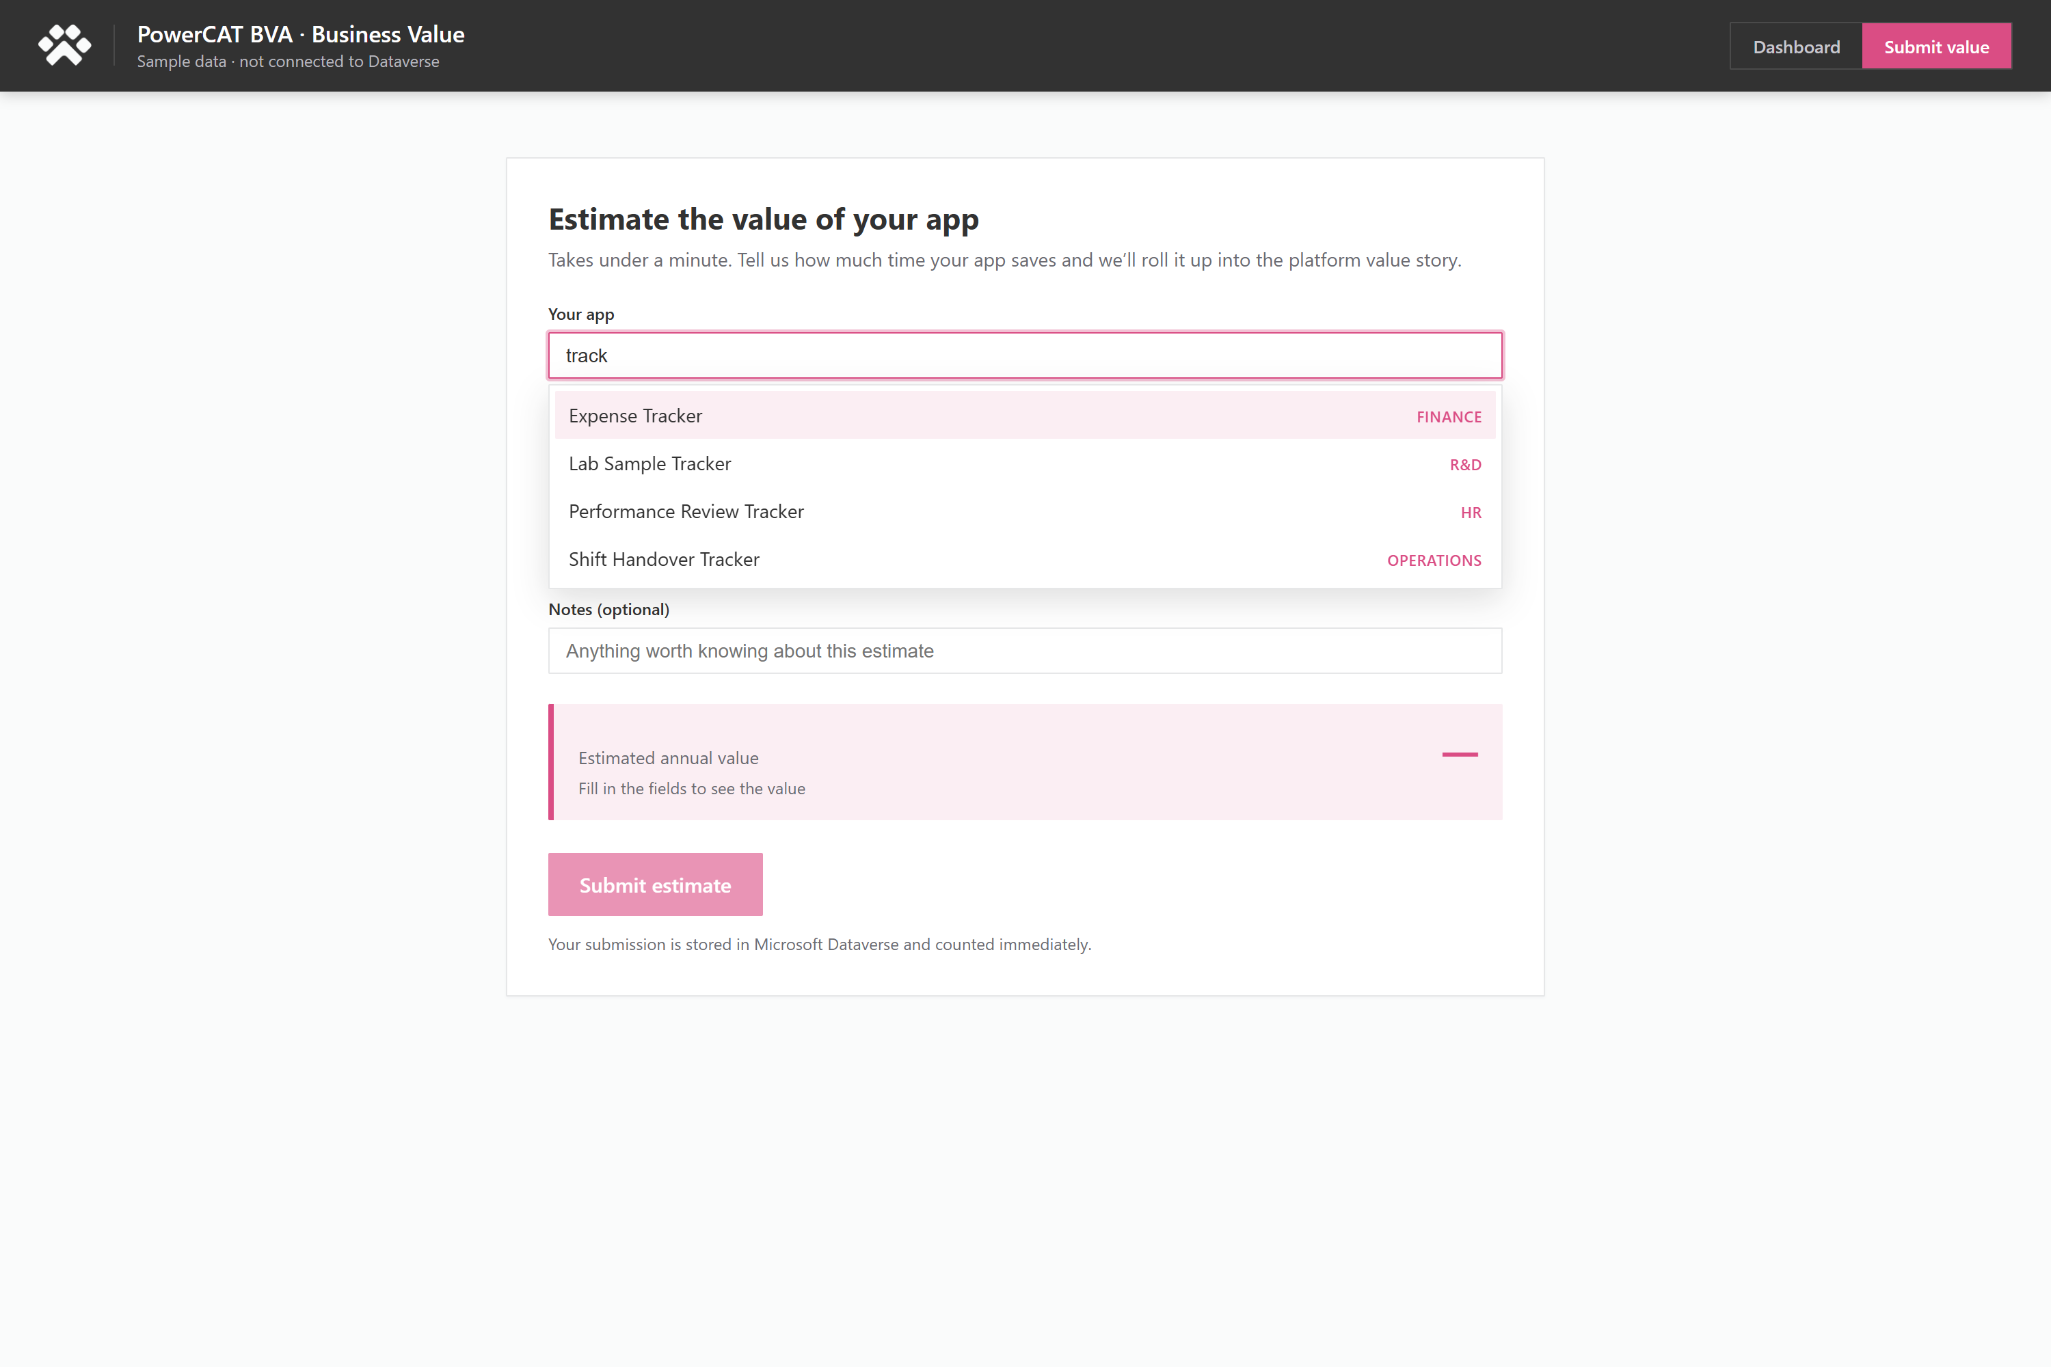
The built-in Submit value form. The app picker is a type-to-search box that scales to thousands of apps.
To submit:
- Find your app: start typing its name in the search box — the list filters instantly and shows the closest matches (handles thousands of apps). Or follow the email link, which pre-selects it.
- Enter hours saved per person per month and the number of people who use it.
- Adjust the blended hourly rate if needed and pick a confidence level.
- Review the live estimated annual value, then choose Submit estimate.
The submission is written to the bvp_valuesubmission table immediately, the app’s status moves to Submitted, and the value is reflected on the dashboard on the next refresh.
Self-contained by design
The submission form lives inside the same Code App as the dashboard — there is no separate Microsoft Form or external site to maintain. One app both captures and visualises value.

6. Deploying the solution
Deploy the three layers in order: tables, flows, then the app. All components live in the unmanaged solution named Business Value (publisher prefix bvp).

6.1 Dataverse tables
- In the target environment, confirm the Business Value solution exists (or create it with publisher prefix bvp).
- Create the bvp_application and bvp_valuesubmission tables and their columns as listed in section 3.
- Publish all customisations.

6.2 Cloud flows
The flows are provided as workflow-definition (WDL) bodies. Either import them into the solution (recommended) or rebuild them in the designer using the definitions as a precise build specification.
- Create the required connections once and reuse them: Microsoft Dataverse, Office 365 Outlook, Office 365 Users, Power Apps for Admins.
- Add each flow to the Business Value solution and bind it to those connections.
- Turn the flows on in order: F1, F2, F3, F4, F5.

6.3 The Code App
From the ValueDashboardApp folder:
npm install
pac code add-data-source -a shared_commondataserviceforapps -c <connectionId> -t bvp_application
pac code add-data-source -a shared_commondataserviceforapps -c <connectionId> -t bvp_valuesubmission
npm run build
pac code push
Set VITE_DATA_SOURCE=dataverse in a .env file to read live data; omit it (or set mock) to run on sample data for demos.

7. Configuration

7.1 Settings
Setting | Default | Where
Blended hourly rate | $45 | Environment variable bvp_BlendedHourlyRate / flow F3
Attestation cadence | 12 months | Flow F2 filter
Reminder window | 7 days | Flow F4
Escalation window | 14 days | Flow F4

7.2 Placeholders to set before go-live
- F2 email link — replace ENVID and VALUEAPPID with your environment id and the published value-app id.
- F3 blended rate — point the lookup at your bvp_BlendedHourlyRate variable, or rely on the built-in $45 default.

Switching the app between live and sample data
Live data: set VITE_DATA_SOURCE=dataverse, rebuild, and push.
Sample data (demos): remove the variable or set it to mock.

8. Day-to-day operations

8.1 Routine checks
- Confirm F1 (Inventory Sync) ran overnight — the app count should track the estate.
- Watch the owner response rate KPI; a falling rate means F2/F4 need attention.
- Review quarantined apps weekly and reassign or retire them.

8.2 Running a value campaign
- Confirm the inventory is current (F1 has run).
- Let F2 send requests, or trigger it manually to start immediately.
- F4 chases non-responders automatically; no manual action needed.
- Read the consolidated result in the dashboard and the weekly F5 snapshot.

8.3 Interpreting the numbers
- Values are estimates supplied by owners; the Confidence column flags how firm each estimate is.
- Use the business-unit filter to brief individual teams on their own contribution.

9. Troubleshooting
Symptom | Likely cause | Fix
Dashboard shows “couldn’t load data” | Data source / connection not wired | Re-run pac code add-data-source; confirm the Dataverse connection.
App shows “old version” banner | Player cached prior build | Click Refresh in the player, or reload with a new sourcetime.
KPIs all zero | No submissions yet, or wrong filter | Run a campaign (F2); set the filter to All business units.
Owners not receiving emails | Outlook connection or F2 off | Check the Office 365 Outlook connection and that F2 is on.
Response rate stuck low | F4 not running | Confirm F4 is on and the reminder/escalation windows are sensible.

10. Appendix

10.1 Choice values
Field | Values
Attestation Status | Not Requested, Requested, Reminded, Submitted, Escalated
Lifecycle Status | Active, Orphaned, Quarantined, Retired
Resource Type | Canvas App, Model-driven App, Code App, Cloud Flow, Agent
Business Unit | Operations, Finance, Supply Chain, HR, Sales, R&D, Other
Confidence | Low, Medium, High

10.2 Glossary
- Attestation — an owner’s confirmation of the value an app delivers.
- Blended rate — an average hourly cost used to convert saved hours into dollars.
- Code App — a Power Apps app built with code (React/TypeScript) on the Power Platform runtime.
- Quarantine — a managed state that pauses an app until its owner re-engages.

Microsoft Power CAT · Business Value Solution User Guide

